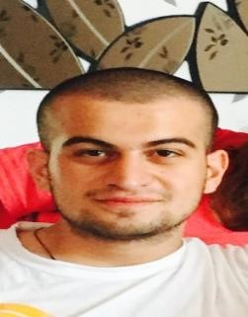Curriculum Vitae

# Personal Details:

# Status: Student

Name and Surname: Irakliy Lomidze

Address: Flat 25a, 3 Lesya Ukrainka Street, Tbilisi, Georgia, 0108 Telephone number: +995599282585

E-mail: [ikatuta7@gmail.com](mailto:ikatuta7@gmail.com)

Nationality: Russian Federation and Georgia

# Education:

2004-2007: Public School No 719 of Moscow

2007-2012: Public School No 1150 of Moscow

2012-2014: Buckswood School

2014-2015: Free University in Tbilisi, Certified Business Administration course 2015-2016: GIPA University in Tbilisi, BSc in Sociology

2017-2020: Wyższa Szkoła Finansów i Zarządzania w Warszawie, 3-year BA Business Management course, Warsaw, Poland(remote studies)

2016-2019: Politechnical College No 50, Moscow, Russian Federation(remote studies)

# Work Experience:

September 2016 - May 2017 – Operator at Viza Petroleum Ltd petrol station, Moscow, Russia November 2017 – July 2018 – Distributor and Merchandiser in Wimm Bill Dann, Moscow, Russia December 2018 – March 2019 – DHL warehouse worker in Warsaw, Poland

March 2022 – November 2022 – Technical customer service representative in Majorel Georgia LLC, Tbilisi, Georgia

December 2022 – January 2023 – Customer service representative in Insoft LLC, Tbilisi Georgia(remote)

# Additional skills:

Language knowledge:

R*ussian: Native Georgian: Native*

*English: Advanced Level (IELTS 6.0 overall, May 2015) Polish: Basic Knowledge*

Excellent MS Office User (Word, Excel, PowerPoint)

Basic knowledge of Python

A and B Category Driving Licence